Project Development Phase
Model Performance Test

Date | 3 October 2026
Team ID | SWTID-2026-9505
Project Name | Implement Client Script & UI Policy (Incident) – ServiceNow
Maximum Marks | 10 Marks

Model Performance Testing:
Project team shall fill the following information in model performance testing template.
S.No. | Parameter | Values | Screenshot
 | Metrics | Regression Model:  Not applicable – the project is a rule-based ServiceNow configuration (UI Policy & Client Scripts); it has no regression model, so MAE, MSE, RMSE and R2 score do not apply.  Classification Model:  Not applicable – no trained classifier, so Confusion Matrix, Accuracy Score and Classification Report do not apply.  Equivalent Functional Validation Metrics:  Test scenarios executed – 8 (FT-01 to FT-08), Passed – 8, Failed – 0, Pass rate – 100%. | 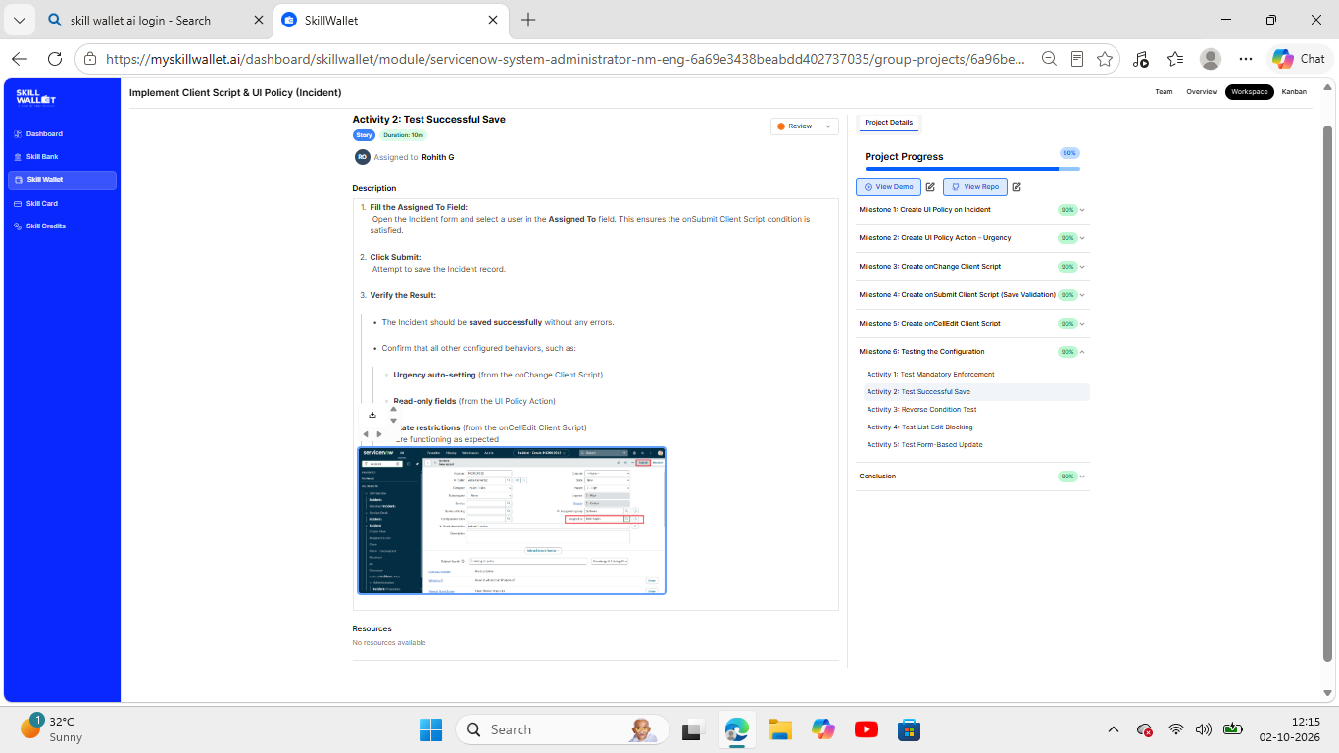
 | Tune the Model | Hyperparameter Tuning - Not applicable (no trainable model or hyperparameters). Behaviour is tuned through configuration: UI Policy conditions (Impact is 1 – High, Reverse if false = true) and Client Script triggers (onChange, onSubmit, onCellEdit).  Validation Method - Manual functional validation in the ServiceNow instance (Milestone 6 – Testing the Configuration): Activity 1 Test Mandatory Enforcement, Activity 2 Test Successful Save, Activity 3 Reverse Condition Test, Activity 4 Test List Edit Blocking, Activity 5 Test Form-Based Update. | 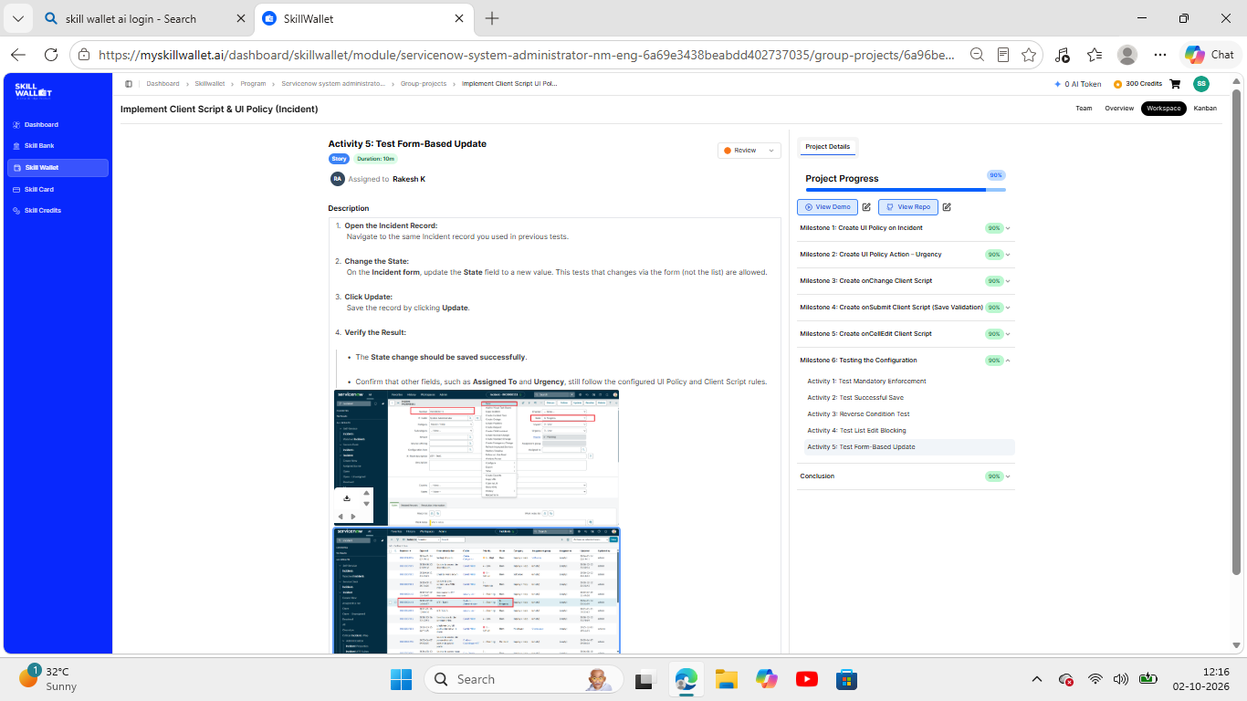

Supporting Screenshots:
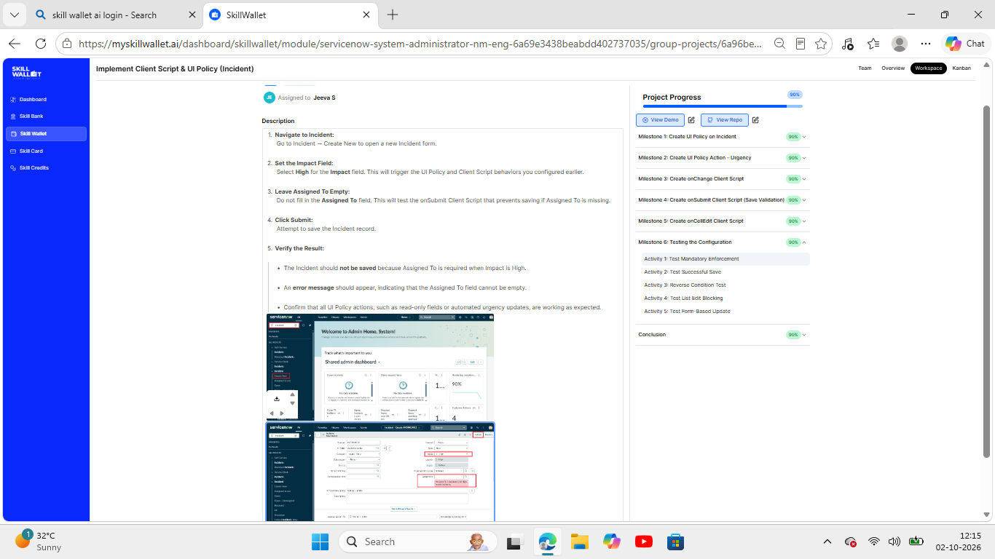
Figure 1: Activity 1 – Test Mandatory Enforcement (Assigned To required when Impact is High)
Figure 2: Activity 2 – Test Successful Save (Assigned To filled; policies and scripts working)
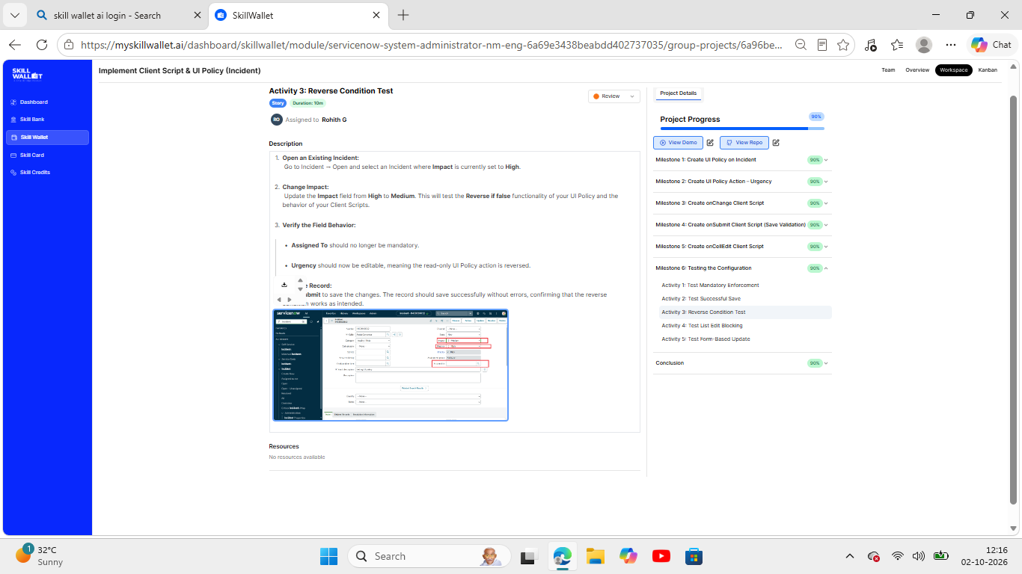
Figure 3: Activity 3 – Reverse Condition Test (Impact changed from High to Medium)
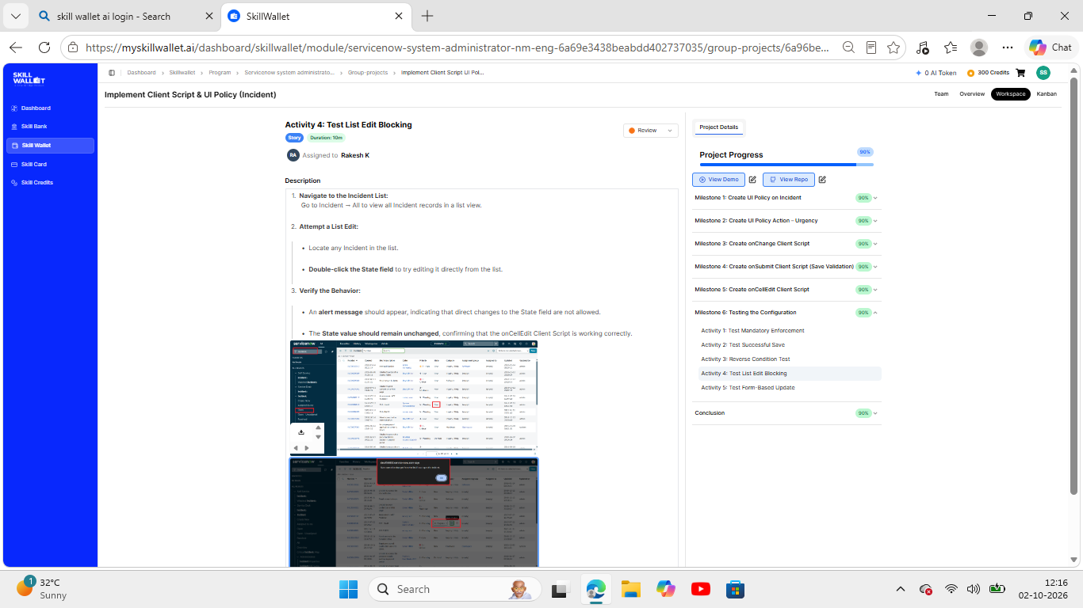
Figure 4: Activity 4 – Test List Edit Blocking (onCellEdit alert on State field)
Figure 5: Activity 5 – Test Form-Based Update (State updated from the Incident form)

